




WEBSITE & DESIGN

DEVELOPMENT

Website Design Document



Website goal
The Read Realm website is designed to be a platform for book lovers to explore books, join book clubs, and connect with fellow readers. The primary goals of the website are to cater to book enthusiasts who enjoy reading and discussing books, particularly in genres like Fantasy and Action & Adventure. Users expect to find a wide range of books, join book clubs, participate in discussions, and manage their profiles. The website aims to inform users about books and book clubs, provide a service for managing book clubs and user accounts, and facilitate community engagement among readers. In summary, the website provides a platform for users to explore books and join book clubs, allows users to create and manage their own book clubs, enables users to interact with other readers through events and discussions, and offers a personalized experience with user profiles and book recommendations.
Scope
The Read Realm website will cover the following scenarios and functionalities:
- User Accounts: Users can sign up, log in, and manage their profiles (update username, password, and profile picture).
- Book Exploration: Users can browse books by genre (Fantasy, Action & Adventure) and view detailed information about each book.
- Book Clubs: Users can join existing book clubs or create their own. Club admins can manage club events and member requests.
- Events: Club admins can create events, and members can view upcoming events.
- Search Functionality: Users can search for books and clubs by name or genre.
- Contact & Social Media: Users can connect with the platform via social media links (Facebook, Instagram, Twitter, Discord).

Requirements
- User Authentication:
  - Users can sign up, log in, and log out.
  - Users can update their profile information (username, password, profile picture).
  - Users can delete their accounts.
- Book Management:
  - Users can browse books by genre (Fantasy, Action & Adventure).
  - Users can view detailed information about each book, including ratings and comments.
  - Users can rate and comment on books.
- Book Club Management:
  - Users can create their own book clubs.
  - Users can join existing book clubs by sending a request.
  - Club admins can accept or decline membership requests.
  - Club admins can create and manage events for their clubs.
- Search Functionality:
  - Users can search for books by title or genre.
  - Users can search for clubs by name or genre.
- Contact & Social Media:
  - Users can access social media links to connect with the platform.

Sitemap

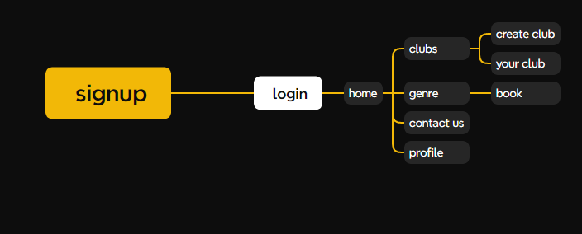

Login page
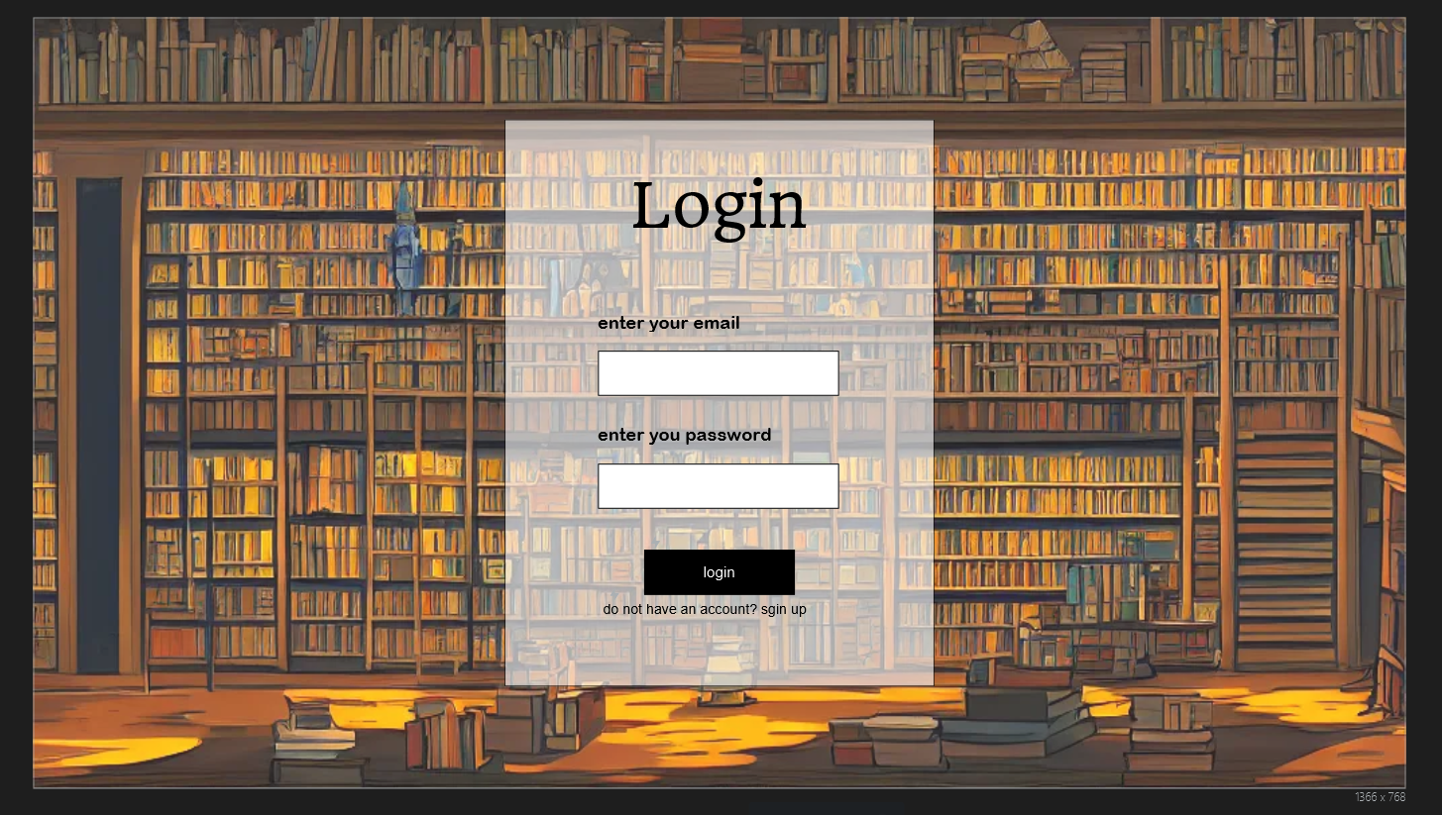signup page
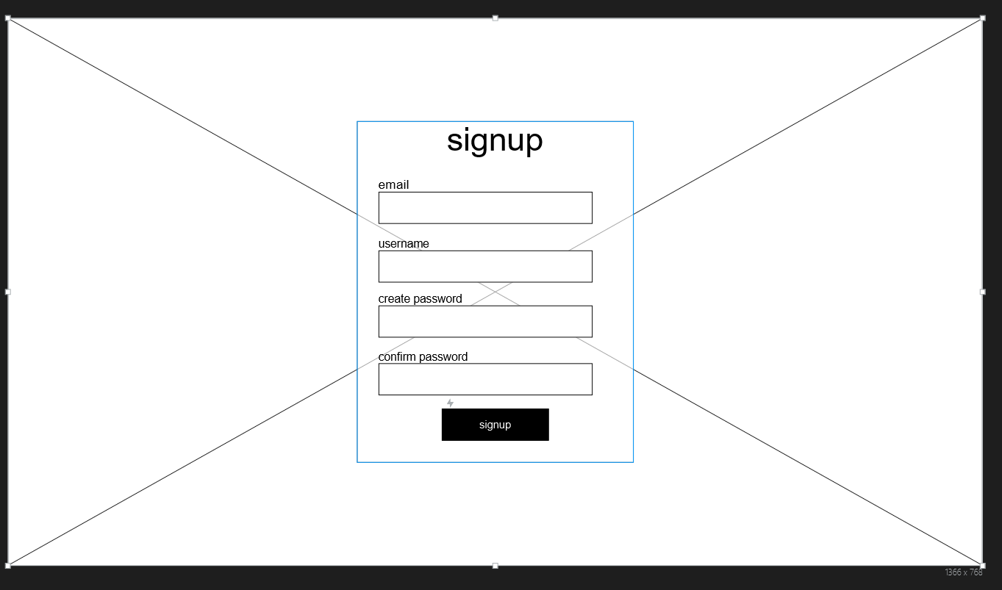

Home page
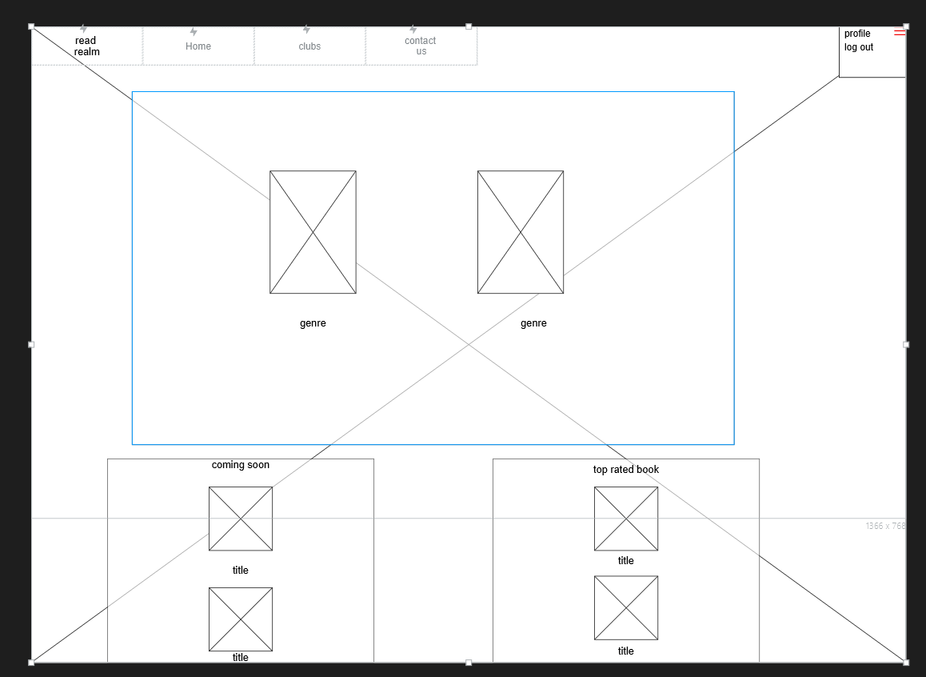
profile
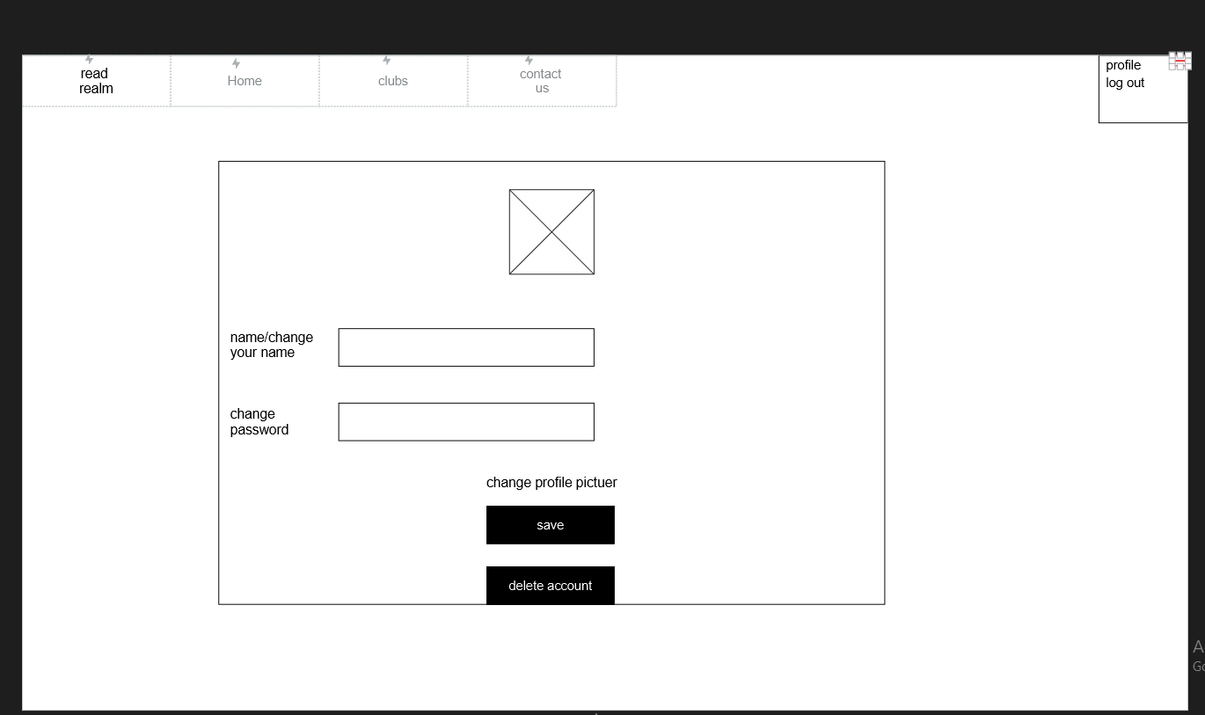
genre page
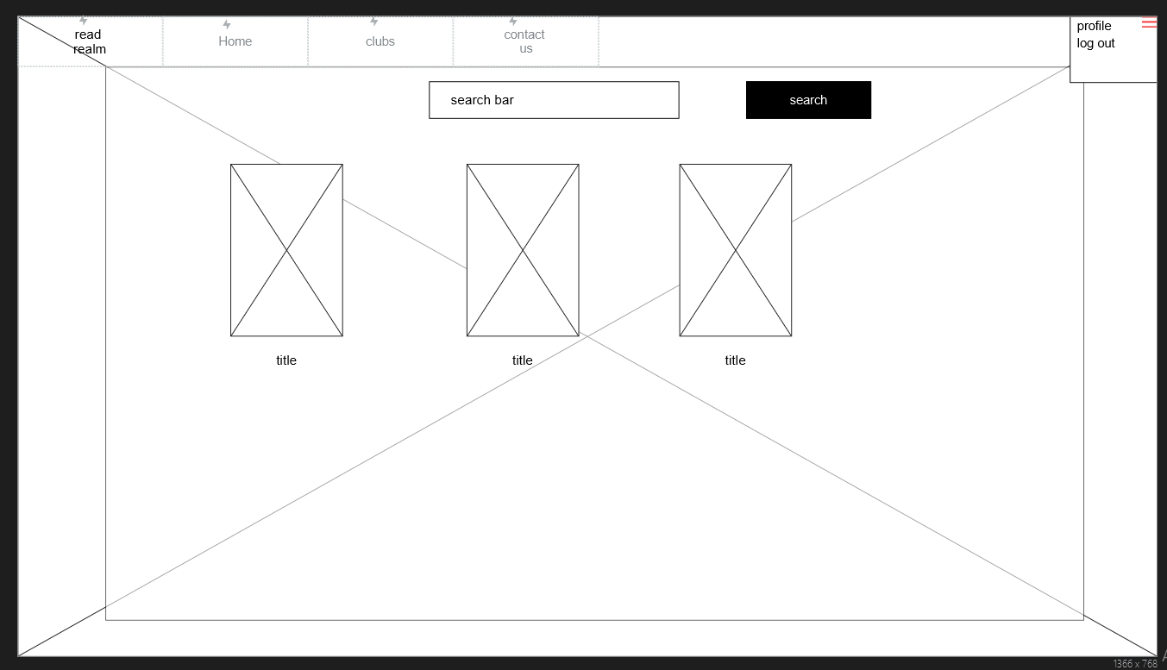

Book page 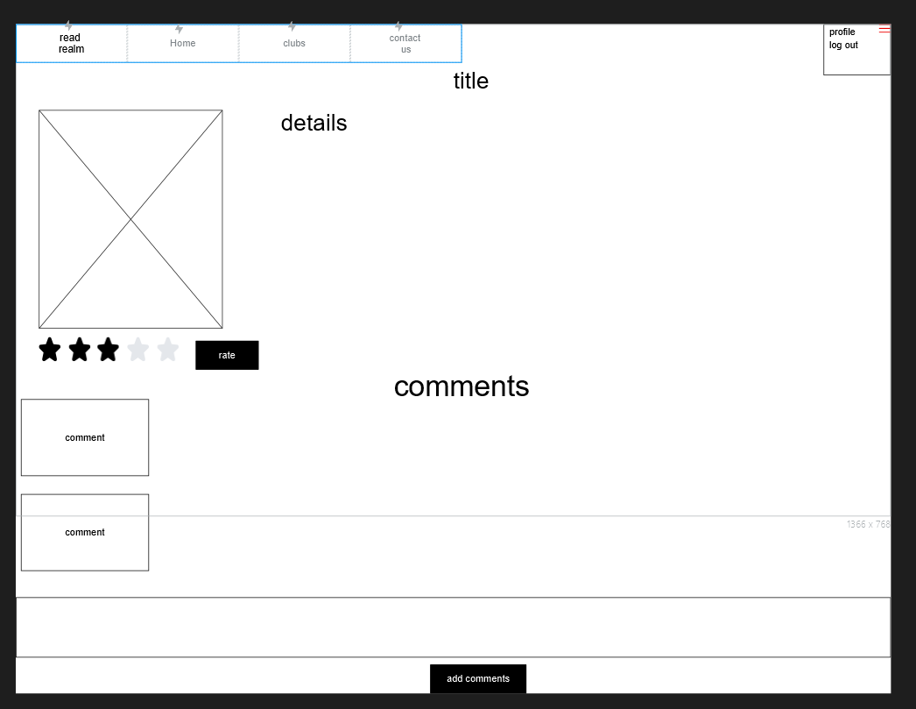

Main club page
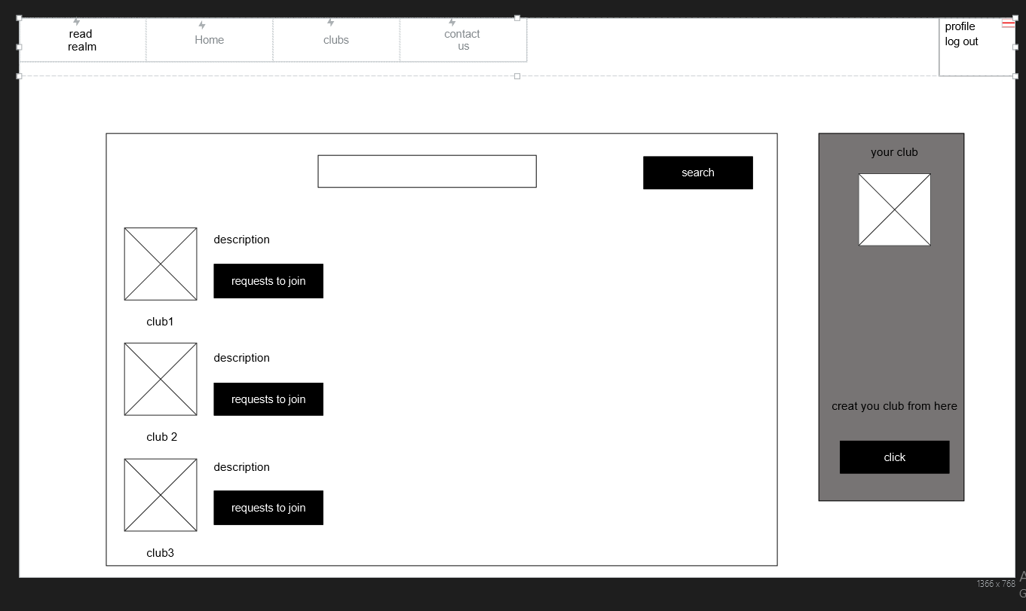create club page
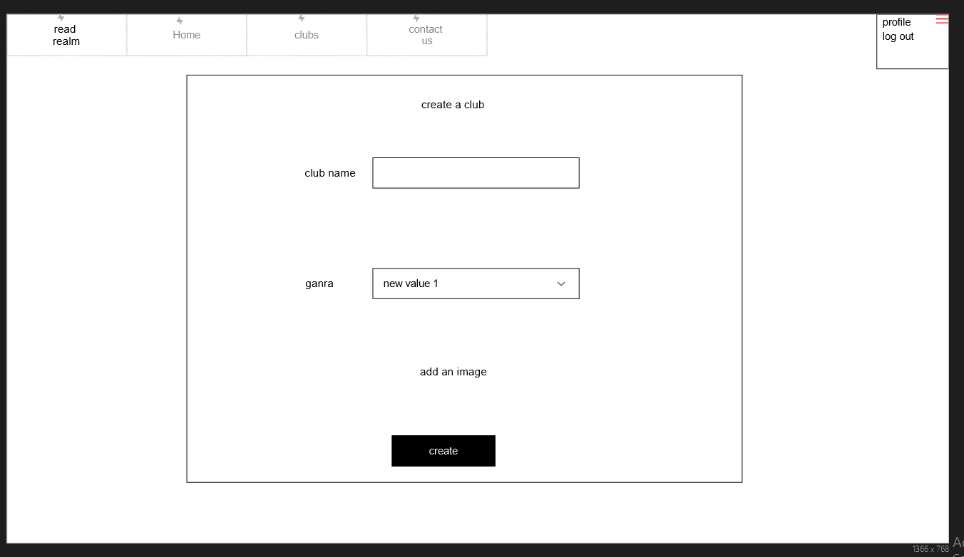

Your club page 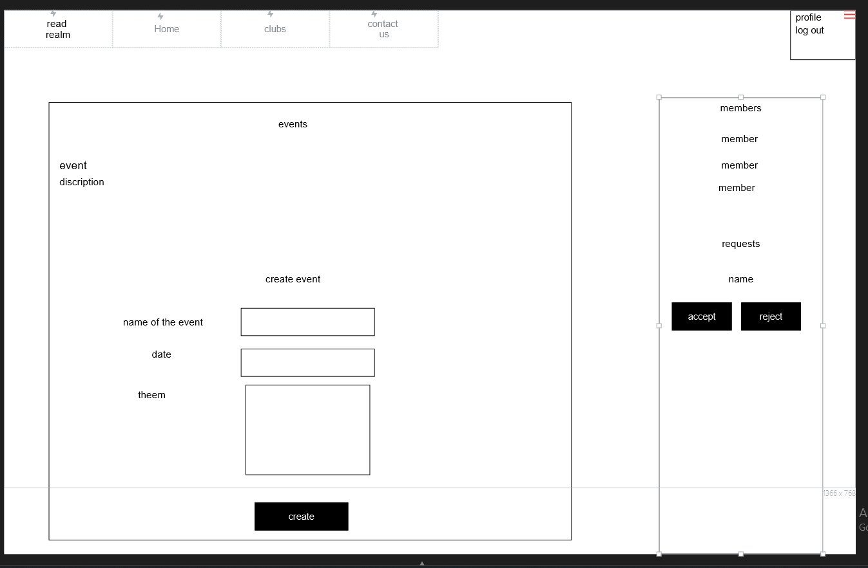

contact page

